Case Report

National Gallery DC

### Tracy’s iPhone [2012-07-15-National-Gallery]

Alexandra Bader

May 20, 2022

# Table of Contents

Case Report

National Gallery DC

Tracy’s iPhone [2012-07-15-National-Gallery]

Table of Contents

Executive Summary

Equipment and Tools

Details of Tracy’s iPhone

Evidence to Establish Personas

Evidence relating to theft of valuable stamps

Evidence relating to defacement of museum art

Plot Timeline

Conclusion

Appendix A: Correspondence Evidence

Appendix B: WiFi and GPS Location Information

# Executive Summary

On January 21, 2016, Digitech Inc. was called in to assist the National Gallery, Washington D.C. (NGDC) case involving the conspiracy associated with the theft of valuable stamps and defacing of museums are at the NGDC.

* Tracy is a suspect in the aforementioned conspiracy.
* As part of the investigation, Tracy’s iPhone was taken into custody.
* Digitech, Inc. was tasked with investigating evidence relevant to the aforementioned conspiracy.

As described fully in the report, Digitech, Inc. made the following findings.

Tracy’s iPhone revealed a conspiracy to steal important stamps from the National Gallery, Washington DC. The conspiracy was between herself, Pat, and King. In addition, Tracy was assisting Carry with her “flash mob,” which happened to be a cover for a plan to damage art at the National Gallery. Tracy was providing Carry National Gallery information to assist with the crime.

### Equipment and Tools

The following list is comprised of equipment and tools used to obtain the findings for this report:

tracy-iphone-2012-07-15-final.E01: this forensic image of Tracy’s iPhone allowed me to investigate the data and determine the findings of this report.

Kali Linux: the operating system used via RDP.

Autopsy: a digital forensics tool, part of a collection of Linux tools known as The Sleuth Kit.

DB Browser for SQLite: database tool allowing the user to create, design, and edit database files.

Google Maps: a tool where you can input longitude and latitude coordinates and find the location.

# Details of Tracy’s iPhone

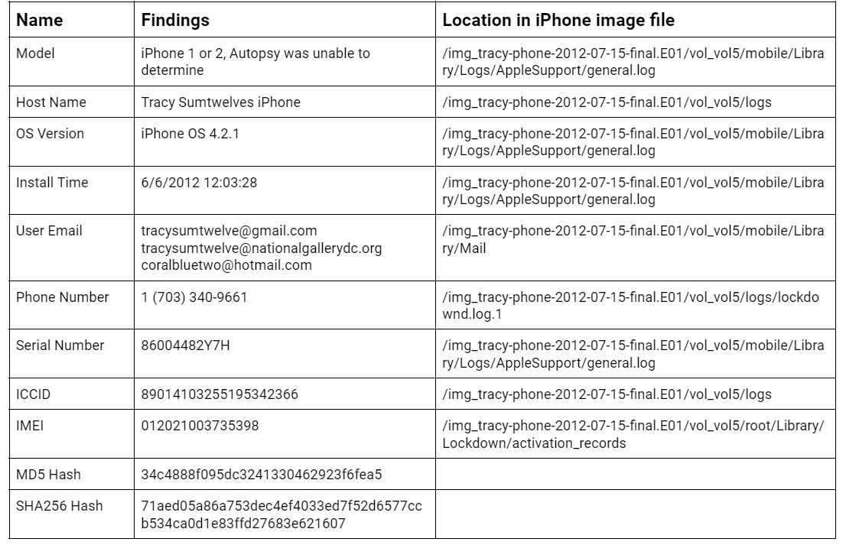

# 

# Evidence to Establish Personas

This section establishes aliases, phone numbers, emails addresses associated with each person, and relationships between each individual.

Tracy: Alias: Coral Blue

Phone Number: (703) 340-9961

Personal Email: tracysumtwelve@gmail.com

Work Email: [tracy.sumtwelve@nationalgallerydc.org](mailto:tracy.sumtwelve@nationalgallerydc.org)

Relationship: Joe (ex-husband), Terry (daughter), Pat (brother)

Status: Accused

Pat: Alias: Perry

Phone Number: (571) 308-3236

Email: patsumtwelve@gmail.com

Relationship: Tracy’s brother; accomplice in conspiracy

Terry:

Phone Number: (703) 829-6071

Email: unknown

Relationship: Tracy and Joe’s daughter

Joe:

Phone Number: unknown

Email: joe.sum.twelve@gmail.com

Relationship: Tracy’s ex-husband; Terry’s father

Carry: Alias: Cat

Phone Number: (202) 725-2124

Email: carrysum2012@yahoo.com

Relationship: Tracy’s associate/friend; implicated in conspiracy to damage National Gallery property with Alex, who has Krasnovian ties and anti-American sentiment

King: Alias: Kart

Email: throne1966@hotmail.com

Relationship: Pat’s acquaintance

Tracy Sumtwelve works at the National Gallery in Washington DC. Tracy and her ex-husband, Joe, have one daughter together (Terry). Joe installed a key-logger onto Tracy’s laptop in order to monitor Terry’s internet use. This keylogger program is what led Joe to uncovering Tracy and Pat’s conspiracy to steal stamps from the National Gallery. Pat is Tracy’s brother, who is a corrupt police detective with the DC Enforcers Bureau. Emails show that Pat is blackmailing King, who has been violating his parole. Pat emailed King that he would tell his parole agent everything unless he agrees to help with the conspiracy, to which King agrees.

Carry is Tracy’s coworker at the National Gallery. Carry was contacted by Alex, who is a Krasnovian supporter and holds strong anti-American sentiments. Carry and Alex know each other through their families. Alex’s plan is to embarrass the United States by defacing foreign artwork (from Majavia) on display at the National Gallery. Alex and Carry come up with the front of a flash mob to hide their true criminal plans. Tracy is assisting Carry in her efforts.

# 

# Evidence relating to theft of valuable stamps

This sub-section provides details regarding the evidence found as it relates to the theft of valuable stamps. It should be noted that the responsibles used their alias names to reference each other throughout most of their communication.

Evidence in Tracy’s iPhone shows that there was correspondence between Tracy, her brother Pat, and Pat’s associate King, with a plan to steal stamps from the National Gallery. Tracy’s phone contained the emails between them as well as photographs of the stamps and of the insurance on them.

Pat accepts Tracy’s proposal via email on 6/19/2012 (Appendix A, Artifact #1).

Tracy mentions the insurance papers in an email to Pat, stating that she is keeping an eye on them in order to find something of significance. Tracy also mentions she needs money to be able to allow her daughter to keep attending the school she is at (Appendix A, Artifact #7).

On 7/3/2012, Tracy sends Pat an email regarding a new exhibit that is coming to the National Gallery, referring to it as a highly valuable stamp collection (Appendix A, Artifact #13).

Pat sent an email to King on 7/6/2012, with Tracy cc’d, telling him that he has a job for him that he can’t pass up (the stamp heist), and blackmails him into helping (Appendix A, Artifact #16).

On 7/9/2012, Tracy sends herself an email (from gmail to hotmail) with 2 zip files containing insurance related documents for the stamp collection (Appendix A, Artifact #18).

On 7/10/2021, King agrees to Pat’s request for assistance with the heist and sends a document with the equipment he requires for his involvement (needs.txt) (Appendix A, Artifact #21).

Tracy attempted to share a location with Pat, which failed. The location she attempted to share was: 2600-2700 24th Rd S, Arlington, VA 22206.

Tracy’s iPhone also contained photographs of the stamps, as well as their insurance paperwork: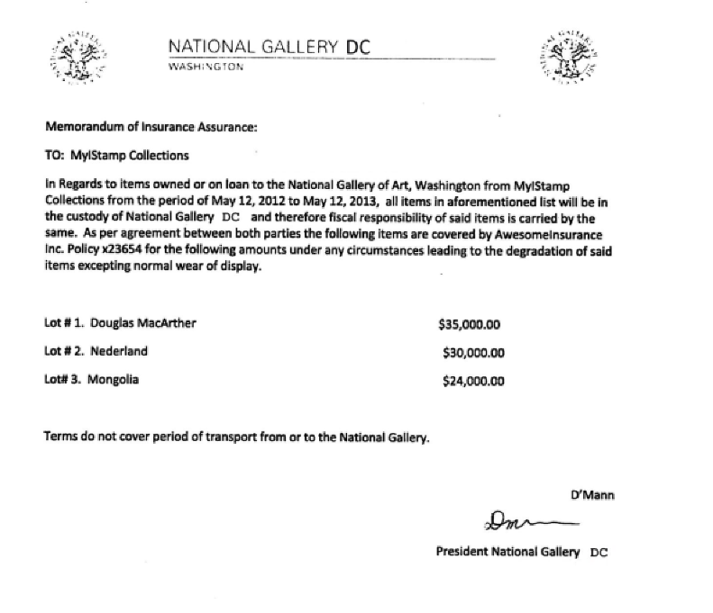

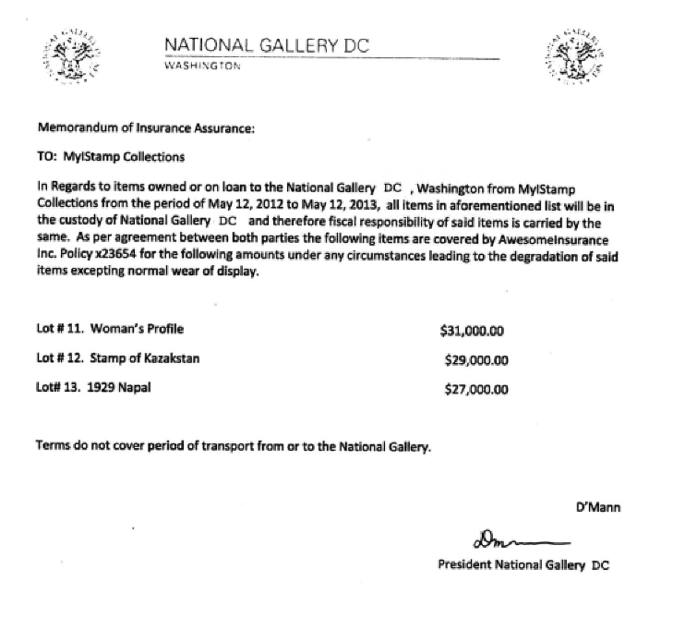

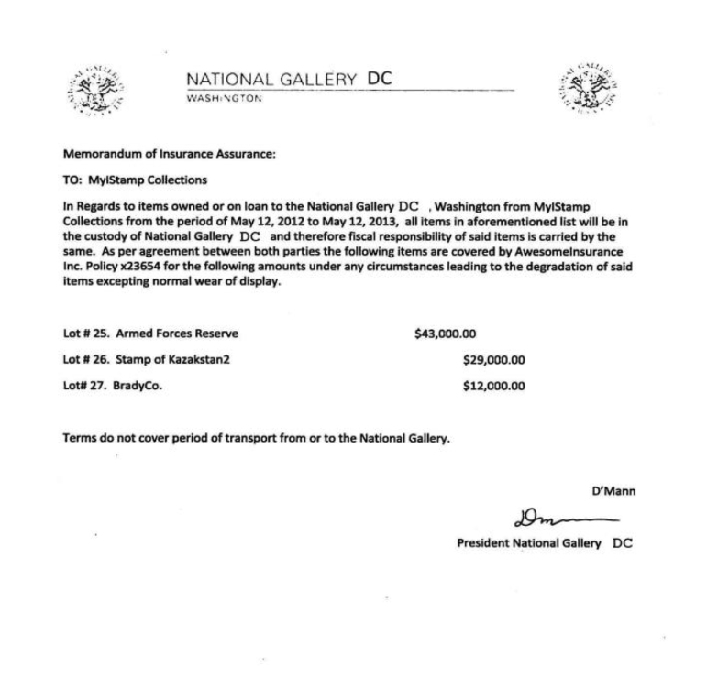

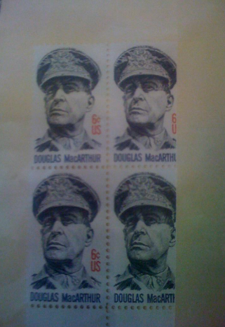(Douglas MacArthur)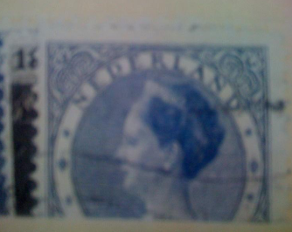 (Nederland) 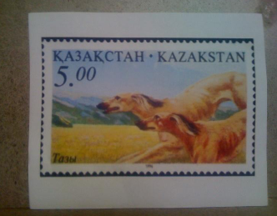(Kazakstan) 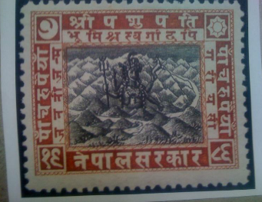(Nepal) 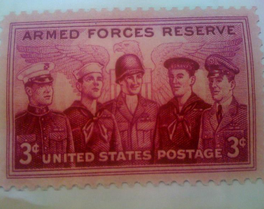(Armed Forces Reserve)(Kazakstan 2)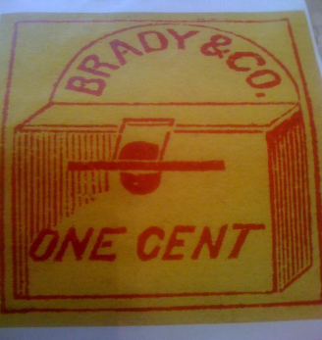(Brady & Co)

# Evidence relating to defacement of museum art

This sub-section provides details regarding the evidence found as it relates to the defacement of museum art.

Tracy’s iPhone revealed that she was in communication with Carry regarding the “flash mob,” a cover for the defacement of artwork at the National Gallery.

Tracy and Carry communicate via email beginning 7/5/2012. In the initial email, Carry suggests she and Tracy meet for lunch on Friday (Appendix A, Artifact #14).

Appendix A, Artifact #19 shows that Carry asked for Tracy’s help sneaking in her tablet to help with the “flash mob” that they had discussed. This email implies that Tracy would be compensated for her help (which is important due to the fact that Tracy is having trouble paying for her daughter’s schooling and does not want her daughter to go live with her father).

Artifact #20 shows Tracy’s response to Carry’s email, and Tracy agrees to help sneak in the tablet. Tracy and Carry agree to meet at the National Gallery the next day at 9 am.

Carry sends Tracy an email asking for the security shift change times and details in exchange for money, and Carry follows by sharing a Google album with Tracy (Appendix A, Artifact # 23-24). Tracy agrees to exchange this information for money with Carry.

Tracy’s text messages with Carry show communication about meeting at Bubba’s Grill (Appendix A, Artifact #32) as well as communication about meeting at a separate place (National Gallery) on 7/11/2012, with mention of Tracy bringing Carry’s tablet (Appendix A, Artifact #48).

# 

# Plot Timeline

An extensive plot timeline (separated by email and SMS) can be seen in Appendix A, by looking at the emails and SMS messages between Tracy and her co-conspirators. The following is a shortened version:

**June 19, 2012:**

8:06 pm: Pat emails Tracy, accepting her proposal

8:26 pm: Pat emails Tracy and requests that she use aliases to communicate

9:38 pm: Pat sends Tracy an email with hidden directions on how to download a VM

**July 3, 2012:**

2:53 pm: Tracy emails Pat that a new exhibit of rare and highly valuable stamps is coming to the National Gallery

**July 5, 2012:**

3:51 pm: Carry asks Tracy to meet with her for lunch.

**July 6, 2012:**

1:00 pm: Tracy and Carry meet for lunch at Bubba’s Grill

3:49 pm: Pat emails King, blackmailing him into assisting with his “proposition”

Correspondence between Tracy, Pat and King continues through July 10.

**July 8, 2012:**

Tracy takes photographs with her iPhone of the stamps that she is interested in stealing

**July 9, 2012:**

2:44 pm: Tracy sends herself the insurance documents for some of the stamp collection.

6:18 pm: Carry emails Tracy and asks for her assistance sneaking her tablet into the National Gallery, citing that it is for the “flash mob” even that they had spoken about earlier

**July 10, 2012:**

1:48 pm: Tracy agrees to help Carry, and they plan on Carry coming to the National Gallery at 9 am the following day.

3:24 pm: King sends a list of equipment that he needs to assist Pat and Tracy.

**July 11, 2012**

12:49 pm: Tracy tells Carry to meet her out front (of the National Gallery) and says that she will take her tablet inside.

5:06 pm: via email, Carry requests Tracy send her the security shift change details for National Gallery, advising that she will be compensated

# Conclusion

Evidence found on Tracy’s iPhone indicated the following:

Tracy, who was using the alias Coral, had conspired with her brother Pat (who used the alias Perry) and Pat’s acquaintance King to plan a heist in which they would steal some of the very rare and very valuable stamps that the National Gallery was set to receive. Terry is also guilty of providing sensitive information regarding the National Gallery to her friend, Carry.

Carry, along with Krasnovian nationalist Alex, were conspiring to deface foreign artwork on display at the National Gallery in an effort to embarrass the United States. This plan was under the ruse of a flash mob, and Carry was able to gain assistance from an inside source (Tracy) to assist with this plan.

Tracy was experiencing financial hardship and issues in her personal life. Tracy wanted to keep her daughter with her part time, but could not afford the tuition at her school. When Tracy asked for help paying for the tuition, Tracy’s ex, Joe, advised he would only pay for the tuition if their daughter was living with him. In a text message found on Tracy’s phone, her daughter mentions that she would rather live with her dad if it meant she could continue going to her current school. These hardships and life challenges seem to have led Tracy to make the decision to partake in nefarious activity with Pat and King, as well as Carry and Alex.

# 

# Appendix A: Correspondence Evidence

This subsection will provide an amalgamation of the email and SMS corresponce evidence.

### 

| Master Timeline of NGDC | | | | |
| --- | --- | --- | --- | --- |
| Artifact # | Timestamp | Header Information | Key Information | Evidence Location |
| 1. | 6/19/2012 20:06:33 | F: patsumtwelve@gmail.com  T: tracysumtwelve@gmail.com  Subject: Paris Speak and answer | Pat emails Tracy letting her know that he has accepted her proposal and asks her to email using her alias for further instructions. | Mailbox Data Structure |
| 2. | 6/19/2012 20:26:47 | F: perrypatsum@yahoo.com  T: tracysumtwelve@gmail.com  Subject: Look me up sometime | Pat (Perry) emails Tracy to ask her to communicate using her alias. | Mailbox Data Structure |
| 3. | 6/19/2012 21:38:59 | F: perrypatsum@yahoo.com  T: coralbluetwo@hotmail.com  Subject: Crazydave by the VMs Attachment: Crazydave1.mp3 | Pat (Perry) emails Tracy (Coral) with instructions to install a Virtual Machine hidden in an audio file. | Mailbox Data Structure |
| 4. | 6/19/2012 21:39:34 | F: perrypatsum@yahoo.com  T: coralbluetwo@hotmail.com  Subject: Re: ??? | Pat (Perry) replies to Tracy (Coral) confirming that he was getting her emails. | Mailbox Data Structure |
| 5. | 6/21/2012 17:43:15 | F: perrypatsum@yahoo.com  T: coralbluetwo@hotmail.com  Subject: Re: Crazydave by the VMs | Pat (Perry) replies to Tracy (Coral) on an email thread about Virtual Machine installation saying that she should listen to some other songs as well.  In the email thread Tracy (Coral) confirms that the instructions sent earlier in the audio file helped her. | Mailbox Data Structure |
| 6. | 6/28/2012 19:31:33 | 6/28/2012 19:31:33  F: perrypatsum@yahoo.com  T: coralbluetwo@hotmail.com  Subject: Whats going on | Pat (Perry) emails Tracy (Coral) asking her to henceforth communicate using the aliases and the Virtual Machine setup to keep them safer. He also indicates that they might have to get into riskier/illegal business since both of them were facing financial hardships.  He tells her that few of his workplace friends were good at these businesses and that he will inform her should something pop-up; in the meantime they should keep discussing some ideas for the same. | Mailbox Data Structure |
| 7. | 6/29/2012 14:21:56 | F: perrypatsum@yahoo.com  T: coralbluetwo@hotmail.com  Subject: Re: Whats going on | This is an email thread between Pat (Perry) and Tracy (Coral) discussing ideas for making some money.  To Pat’s suggestion that they use the Virtual Machines and aliases to communicate and keep looking for ways to make money, Tracy replies that she will keep her eyes open for opportunities and insists that Pat try to get in on some business soon, since her kid didn’t want to change schools. She also indicates that she is paying attention to documents, especially insurance papers, so that she could identify something of potential. Pat assures that he will make something happen although he is nervous because IA has been sniffing around. | Mailbox Data Structure |
| 8. | 6/29/2012 14:31:36 | F: perrypatsum@yahoo.com  T: tracysumtwelve@gmail.com  Subject: hey sis | Pat (Perry) emails Tracy addressing her as ‘sister’ and enquires about Terry. Asks her to check in with Coral with whom he has been planning some things. He also suggests all of them going together for dinner as friends.  He asks Tracy to check in with Coral.  Possible misdirection attempted by referring to Coral as a third person in the narrative. | Mailbox Data Structure |
| 9. | 6/29/2012 15:21:35 | F: perrypatsum@yahoo.com  T: coralbluetwo@hotmail.com  Subject: Re: Whats going on | Pat (Perry) replies to the email thread allaying Tracy’s (Coral) concern about IA sniffing around him. Tracy in her earlier email in the thread says that although nothing interesting has turned up yet she expects something soon. Pat in his email mentions that they can certainly get the job done if something like what they had earlier discussed pops up. | Mailbox Data Structure |
| 10. | 7/2/2012 16:13:18 | F: perrypatsum@yahoo.com  T: coralbluetwo@hotmail.com  Subject: Re: Some good news | Email Thread: Some good news  Tracy (Coral) emails Pat (Perry) mentioning that some interesting foreign exhibit is going to happen and that from assessing the paperwork she feels that it would be a big deal.  Pat (Perry) replies back feeling hopeful about this being the opportunity they were looking for. | Mailbox Data Structure |
| 11. | 7/2/2012 20:00:31 | F: perrypatsum@yahoo.com  T: coralbluetwo@hotmail.com  Subject: Re: Some good news | Email thread: Some good news  Following up on the earlier email about the exhibit, Tracy (Coral) mentions going through documents related to the exhibit from which she found that the exhibit is worth a lot of money but the shipping cost is very low comparatively.  Pat (Perry) emails back saying that such a thing may mean that the exhibit is something small which would be a very good thing for them. | Mailbox Data Structure |
| 12. | 7/3/2012 13:29:37 | F: joe.sum.twelve@gmail.com  T: tracysumtwelve@gmail.com  Subject: Re: Regarding Terry | Email Thread: Regarding Terry  Tracy emails Joe asking whether he could help her with Terry’s tuition this year since it is becoming too expensive for her.  Joe replies back saying that he won’t be paying Terry’s tuition if she is not living with him. | Mailbox Data Structure |
| 13. | 7/3/2012 14:53:04 | F: perrypatsum@yahoo.com  T :coralbluetwo@hotmail.com  Subject: Re: Some good news | Email Thread: Some good news  Tracy (Coral) emails Pat (Perry) saying that the exhibit is a rare and highly valuable stamp collection and that maybe this is their opportunity.  Pat (Perry) replies to Tracy (Coral) asking her to collect as much information as possible about the stamp exhibit and that in the meantime he would look into options for pulling off the heist. | Mailbox Data Structure |
| 14. | 7/5/2012 15:51:31 | F: carrysum2012@yahoo.com  T: tracysumtwelve@gmail.com  Subject: Long time no see... | Carry reaches out to Tracy asking her if they could meet-up for lunch and suggests this Friday. She also mentions that through Facebook she realized that Tracy was having a hard time recently. | Mailbox Data Structure |
| 15. | 7/6/2012 15:27:51 | F: patsumtwelve@gmail.com  T: tracysumtwelve@gmail.com  Subject: Re: Good News | Email Thread: Good News  Tracy emailed Pat saying that she spoke with Coral and that Coral got some great news about her job and suggested that Pat catch up with Coral.  Pat replied back saying that he knows a guy called King. | Mailbox Data Structure |
| 16. | 7/6/2012 15:49:31 | F: patsumtwelve@gmail.com  T: throne1966@hotmail.com  Cc:coralbluetwo@hotmail.com  Subject: can't pass up | Pat emails King with Tracy (Coral) in cc, saying that he has a lucrative proposition, a heist at national gallery. He also threatens King to comply or else he would put King’s parole in jeopardy. | Mailbox Data Structure |
| 17. | 7/6/2012 17:59:24 | F: patsumtwelve@gmail.com  T: tracysumtwelve@gmail.com  Subject: Re: Good News | Email Thread: Good News  Tracy suggests they (meaning King, Tracy and Pat) should hang out sometime.  Pat emails Tracy with account login information for:  coralblue@hotmail.com  Password: legalBee | Mailbox Data Structure |
| 18. | 7/9/2012 14:44:11 | F: tracysumtwelve@gmail.com  T: coralbluetwo@hotmail.com  Subject: things | documents.zip is a compressed, en ZIP folder containing 3 insurance documents related to stamps.  docs.zip is an encrypted ZIP folder containing 3 insurance documents related to stamps. | /mobile/Librar y/Mail/POP- coralbluetwo @hotmail.com @pop3.live.co m/INBOX.mbo x/Messages/8 A3BD06F- CDB1-4453- 9C69- 77E06823F2A E.emlx |
| 19. | 7/9/2012 18:18:47 | F: carrysum2012@yahoo.com  T: tracysumtwelve@gmail.com  Subject: Re: Long time no see.. | Email Thread: Long time no see... Tracy thanked Carry for the lunch.  Carry emails Tracy asking for help sneaking in a tablet for a flash mob event they had spoken earlier about. Carry suggests that Tracy would be compensated in some way for the help. | Mailbox Data Structure |
| 20. | 7/10/2012 13:48:40 | F: carrysum2012@yahoo.com  T: tracysumtwelve@gmail.com  Subject: Re: Long time no see... | Email Thread: Long time no see…  Tracy agrees to help Carry sneak in the tablet and asks when Carry would like to get in to take a look around the gallery.  Carry replies saying that this would be a big help and asks if she could come around 9 tomorrow. | Mailbox Data Structure |
| 21 | 7/10/2012 15:24:57 | F: patsumtwelve@gmail.com  T: coralbluetwo@hotmail.com  Subject: Fwd: can't pass up  Attachment: needs.txt | Email Thread: can't’ pass up  King agrees to help with the heist and sends in a document with equipment required for it. The attached document is saved as a ‘txt’ file.  Pat forwards that email to Tracy (Coral)  *needs.txt is a pdf file which was saved with a wrong extension. | /mobile/Librar y/Mail/POP- coralbluetwo @hotmail.com @pop3.live.co m/INBOX.mbo x/Messages/9 F0508B8- 04FB-490E- A7F0- 3E23B0E7C5 9B.emlx |
| 22. | 7/11/2012 17:06:19 | F: carrysum2012@yahoo.com  T: tracysumtwelve@gmail.com  Subject: Re: Long time no see... | Email Thread: Long time no see  Tracy confirms the meet at 9 tomorrow.  Carry wants Tracy to pass her information regarding shift changes of security. She suggests that Tracy would be well compensated for the information.  Tracy confirms that she will give the security shift information Carry requested in exchange for money but asks Carry to be careful with it.  Carry replies asking Tracy not to worry and says “It will be gun”. | Mailbox Data Structure |
| 23. | 7/11/2012 19:28:53 | F: "Google+" <noreply- 5dd47ca1@plus.google.com>  T: tracysumtwelve@gmail.com  Subject: Carry Carsumtwotwelve added you on Google+ | Email Thread: Long time no see  Previous email from the thread from Carry asking for the security shift details from Tracy. | Mailbox Data Structure |
| 24. | 7/11/2012 23:22:03 | F: "Carry Carsumtwotwelve (Google+)" <replyto- 748d3d22@plus.google.com>  T: tracysumtwelve@gmail.com    Subject: Carry Carsumtwotwelve is sharing with you on Google+ | Notification from Google+ informing Tracy that Carry had shared an album. | Mailbox Data Structure |
| 25. | 7/12/2012 16:12:07 | F: "Carry Carsumtwotwelve (Google+)" <replyto- 748d3d22@plus.google.com>  T: tracysumtwelve@gmail.com  Subject: Carry Carsumtwotwelve is sharing with you on Google+ | Notification from Google+ informing Tracy that Carry had shared an album. | Mailbox Data Structure |
| 26. | 7/12/2012 18:03:51 | F: carrysum2012@yahoo.com  T: tracysumtwelve@gmail.com  Subject: Re: Long time no see... | Email Thread: Long time no see...  Tracy emailed Carry asking her what she meant by “It will be gun”.  Carry replies saying that it was a typographical error and she meant “It will be fun”. | Mailbox Data Structure |
| 27. | 6/12/2012 21:25:04 | F: Pat  T: Tracy | Pat asks Tracy about her plans for the weekend | SMS |
| 28. | 6/13/2012 17:30:28 | F: Terry  T: Tracy | I'm going out with dad after school for pizza! Thought I'd let you know if you planned to cook. T | SMS |
| 29. | 6/13/2012 18:30:38 | F: Tracy  T: Pat | Tracy replies to Pat's message saying that she has no big plans and enquires about his plans. | SMS |
| 30. | 6/13/2012 18:33:46 | F: Tracy  T: Terry | Ok, sounds good. | SMS |
| 31. | 7/3/2012 14:04:32 | F: Terry  T: Tracy | Terry replies back saying that she doesn’t want to switch schools and would rather stay with her dad and continue at Prufrock | SMS |
| 32. | 7/5/2012 18:18:23 | F: Carry  T: Tracy | Carry sets up the time and location as 1pm at Bubba’s grill for meeting with Tracy | SMS |
| 33. | 7/5/2012 18:20:26 | F: Tracy  T: Carry | Tracy confirms the meeting time and location | SMS |
| 34. | 7/6/2012 15:02:19 | F: Tracy  T: Pat | Tracy asks Pat to give her a call | SMS |
| 35. | 7/6/2012 15:08:37 | F: Pat  T: Tracy | Pat says he is busy and suggests calling later | SMS |
| 36. | 7/6/2012 15:11:54 | F: Tracy  T: Pat | Tracy says its important and insists that Pat call her soon | SMS |
| 37. | 7/6/2012 15:13:31 | F: Pat  T: Tracy | Pat says he will call in 5 min | SMS |
| 38. | 7/6/2012 15:18:50 | F: Pat  T: Tracy | Pat calls Tracy and they speak for 4 min 4 secs. | SMS |
| 39. | 7/6/2012 16:27:16 | F: Carry  T: Tracy | Carry messages saying she has a table inside | SMS |
| 40. | 7/6/2012 16:27:50 | F: Tracy  T: Carry | Tracy replies back saying that she will be there. | SMS |
| 41. | 7/10/2012 15:26:19 | F: Pat  T: Tracy | Pat messages Tracy telling her about the email and informing that the attachment needs to be changed to pdf. He asks Tracy to tell this information to Coral. | SMS |
| 42. | 7/10/2012 15:58:04 | F: Tracy  T: Pat | Tracy acknowledges the email and message. | SMS |
| 43. | 7/10/2012 16:37:09 | F: Tracy  T: Pat *Failed | Tracy tried to share the following location with Pat via MMS message but it failed. Location: 2600-2700 24th Rd S, Arlington, VA 22206 | SMS |
| 44. | 7/10/2012 17:18:38 | F: Tracy  T: Terry | Tracy messages Terry for Lunch | SMS |
| 45. | 7/10/2012 18:19:24 | F: Tracy  T: Terry | Tracy messages Terry that she is back at work. | SMS |
| 46. | 7/10/2012 18:58:24 | F: Terry  T: Tracy | Terry messages Tracy saying she is busy and suggests meeting up over the weekend if her dad isn’t busy. | SMS |
| 47. | 7/11/2012 12:41:45 | F: Carry  T: Tracy | Carry messages Tracy informing that she is almost there (National Gallery) | SMS |
| 48. | 7/11/2012 12:49:08 | F: Tracy  T: Carry | Tracy replies to Carry asking her to meet out front. She says that she will take the tablet in. | SMS |
| 49. | 7/13/2012 1:02:10 | F: Terry  T: Tracy | I really want to go to Dad's this weekend. He said he'll take me shopping for school | SMS |

### 

# 

# Appendix B: WiFi and GPS Location Information

# 

| Location Information | | | | |
| --- | --- | --- | --- | --- |
| Artifact # | Timestamp | Header Information | Body | Map Screenshot |
| 1 | 6/13/2012  7:01:21 pm (UTC) | Cell Location  38°52'39.6"N 77°06'55.7"W | Location: Virginia Tech Research Center - 900 N Glebe Rd. Arlington, VA 22203 |  |
| 2 | 6/13/2012  7:01:22 pm  (UTC) | WiFi Location  38°52'50.0"N 77°06'55.9"W | Location: Virginia Tech Research Center - 900 N Glebe Rd. Arlington, VA 22203 |  |
| 3 | 7/2/2012  4:19:23 pm  (UTC) | Cell Location  38°52'51.3"N 77°07'01.6"W | Location: 4600 Fairfax Dr. Arlington, VA 22203 |  |
| 4 | 7/2/2012  4:19:24 pm  (UTC) | WiFi Location  38°52'47.7"N 77°06'52.6"W | Location: 800 N Glebe Rd. Arlington, VA 22203 |  |
| 5 | 7/8/2012  12:33 pm  (EDT) | Cell Location  38°53'30.0"N 77°01'24.6"W | Location: National Gallery of Art  Washington DC 20408 |  |
| 6 | 7/10/12  4:31 pm | Wifi Location  38°50'54.0"N 77°04'55.9"W | Location: 2693 24th Rd S, Arlington, VA 22206  ** The location Tracy attempted to send to Pat via MMS on 7/10/12 @ 4:37 pm ** |  |
|  |  |  |  |  |
|  |  |  |  |  |
|  |  |  |  |  |

### 

**EMAIL CONTENT:** /mobile/Library/Mail

**SMS CONTENT:** /mobile/Library/SMS/sms.db & Class Work via GitLab

**CALL DATA DATA:** /wireless/Library/CallHistory/call_history.db

**WIFI AND CELL PHONE LOCATION DATA:** /root/Library/Caches/locationd/consolidated.db